CROESUS

What is Problem-Based Learning (PBL)?
Problem-based Learning (PBL) is a student centred pedagogy in which students leaner about a subject through the experience of solving a problem. The goals of PBL are to help students develop flexible knowledge, effective problem solving skills, self-directed learning, effective collaboration skills and intrinsic motivation. Problem-based learning is a style of active learning.
Traditionally PBL was delivered to a group of 6-8 students using a linear paper copy of a patient scenario. With the use of online virtual patient authoring systems these can now be delivered online as branched virtual patient scenarios.

What is a Virtual Patient (VP)?
A Virtual Patient (VP) is an interactive computer simulation of real-life clinical scenarios for the purpose of medical training, education and assessment. Using VPs for PBL sessions allows the students in the group to make decisions in a safe environment and practice patient management decision making. There are many forms of VPs online which range from high fidelity immersive virtual world type games to low fidelity text on web pages.

Why use VPs for PBL?
VPs allow:
- the learners to practice their clinical reasoning in a safe environment with feedback
- give exposure to a greater range of different scenarios
- further resources to be embedded within the scenario
- better collaboration between learner
- the learner to change their thought pattern to avoid medical error in their practice

How to Author Virtual Patient

The software
You can author virtual patients by creating a series of webpages and links however there are now sophisticated software which allow you to visualise the whole scenario by creating a mind map. The open source software Open Labyrinth was one of the first branching VP authoring software. http://openlabyrinth.ca/

Create your Virtual Patient / The 7-step creation model
The fundamental basis of case creation is to set up boxes containing text, using OL within the visual editor.
- Decide on how the scenario will be used
Is your PBL session in a small group setting or large? Scenarios will be created differently depending on the numbers of students this will have an impact on the structure of the scenario.

- Decide on a suitable scenario
Here you want a reasonably common situation involving a patient presentation that requires multi-step management. In medical education examples might include a man with chest pain, a vomiting baby, a woman with post menopausal bleeding etc. Answer the following questions when thinking about your scenario:
What subject area/ speciality will your scenario cover?
What academic level is the scenario aimed at?
What are the learning outcomes you hope the students to cover in this scenario?

- Create the first node(s)
Create your first node of your scenario ensuring you cover the following information:
Where is the case going to be set? Accident and emergency , General Practitioner surgery, Patients home?
Who will the learner be in the scenario? Paramedic, nurse, Final Year Doctor?
Who is your patient(s)? Name, age, appearance, symptoms?

In this first node ensure not to reveal too much information like patient history information, it is a good idea to give small bits of vital information at a time so that the group can discuss all hypotheses.

- Create an ideal pathway
Create an ideal pathway through the start to the end of the case. This does not have to be the only way through the case, but will give an overview of the number of steps that will need to get from the start to the end of the case. Identify some key nodes which are points of management within the case and are places you are likely to have branching/options.

Key nodes can act as a gateway to the next part of the case. They are usually steps in clinical actions or clinical management. There will typically be 3-5 key nodes in a case– for instance they might be triage in A+E, completion of resuscitation, admission to the ward, cardiac catheterisation and discharge home for a patient with a myocardial infarction.

- Put in branching boxes from the key nodes or management nodes in your case
These will represent the various pathways within the case and the choices connecting them. Here you will need to think what might be reasonable in a real situation, and use this as the basis for naming the choices. Further connections may also be made at this stage, to create alternative routes through the case. Typically we advise not to have more than 6 choices at a branching node.

- Prune the case
Dead end branches need an explanation and redirection back to an earlier node or move forward in the scenario. Provide feedback in the non-ideal pathways that students can learn from the consequences of their actions. Points within the case where you have more than four options consider reducing these to the most realistic options, ensuring all options are valid and viable.

Ask colleagues to review the case at this stage ensuring the case is at the appropriate level and is correct for content. If possible test the scenario with final year students to get their feedback.

- Enrich with media
The skeleton of the case is now complete. Depending on time and resources, the case can now be complemented with additional features – e.g. clinical photography, video, sound. It can be linked to other sources of information, such as on-line course materials and relevant websites.
This approach may produce a case of for example 10 steps, with perhaps 30-50 ‘pages’. Approximately 10-20 hours is required to create such a case for one individual working alone.

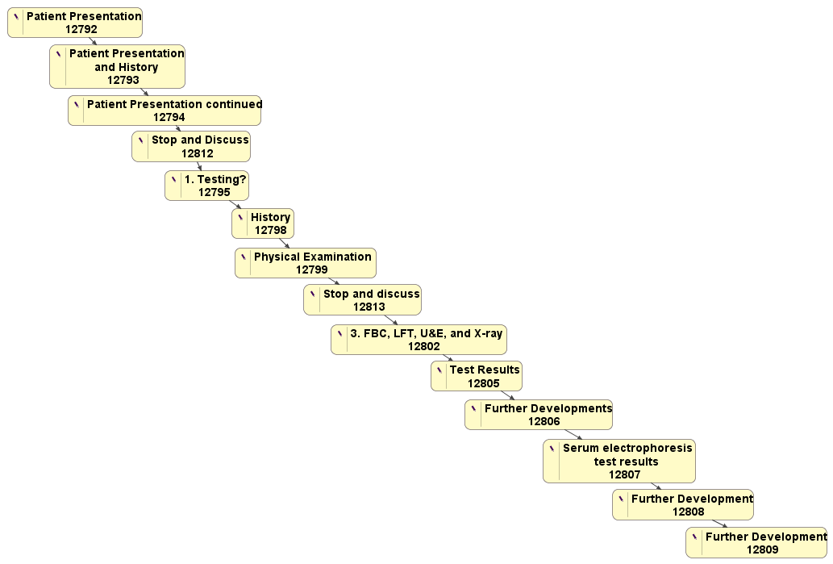
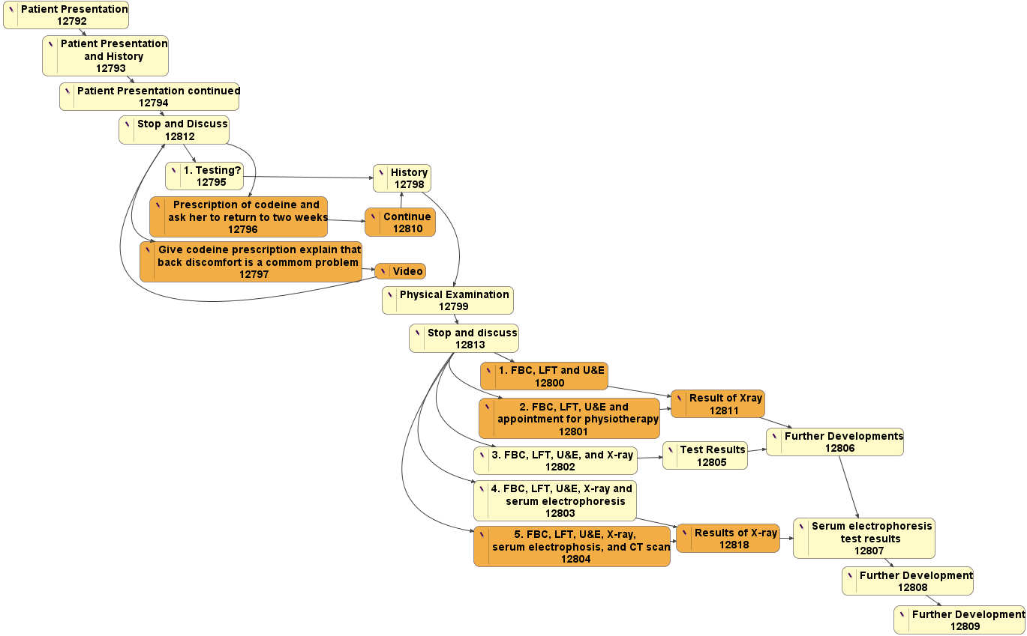

Tips when creating virtual patients
- Provide feedback but from the consequence of the decision not from a senior member of staff pointing out your wrong.
- Don’t give instant negative feedback as its doesn’t provide any learning
- Be realistic – How does a patient take their temperature at home rectally!?
- Don’t give too much information away
- Provide a good story and distractions
- Make all options realistic and valid but they should be an action not hypotheses
- There should be plausible reasons for taking an actions – use the narrative in the text to make the choices more plausible.
- Option points should try to help the learner hit one of the objectives you have set out in the scenario for the student to learn.

Hmelo-Silver, Cindy E. (2004). "Problem-Based Learning: What and How Do Students Learn?". Educational Psychology Review 16 (3): 235. doi:10.1023/B:EDPR.0000034022.16470.f3.
Ellaway R, McGee JB, Fors U, Albright S. Virtual Patients. Medbiquitous Consortium 2006 Annual Meeting; April 25–27; Baltimore, MD.

